Spot Elevation Markers Dev Map

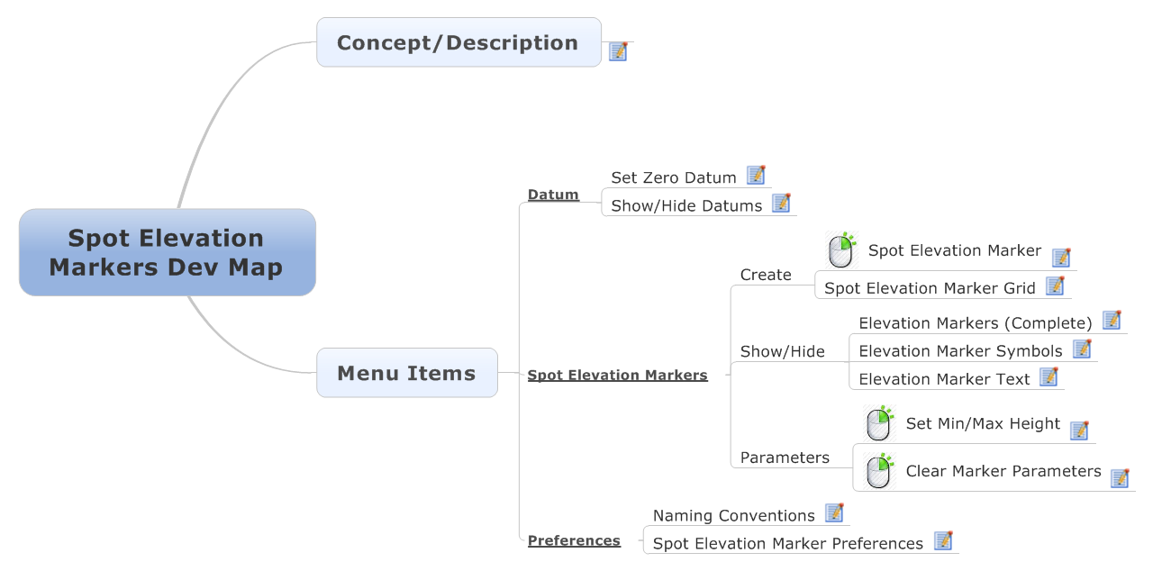

Concept/Description

This plug in's current purpose is to allow the User to click on any given object in SketchUp (point, line, face) and the script will automatically create a Spot Elevation Marker that references the z-height of the object at the selected point, and will update based on changes made to the terrain (likely a manual refresh to prevent lagging/crashes). Additionally, the user can set their own Zero Datum (ground plane) for additional flexibility.

Menu Items

Datum

Set Zero Datum

Allows User to define the location of the Zero Datum. All spot elevation markers will reference this plane for their measurements.

Show/Hide Datums

Allows User to Show/Hide Datum Planes based on their preference.

Spot Elevation Markers

Create

  
Spot Elevation Marker

This Option allows the User to create a single Spot Elevation Marker; which will display the Z-height of the point (or location) chosen.

Spot Elevation Marker Grid

Creates a User-defined grid of single spot elevation markers.

Show/Hide

Elevation Markers (Complete)

Toggles visibility of all Spot Elevation Markers Globally

Elevation Marker Symbols

Toggle visibility of all Spot Elevation Marker Symbols Globally.

Elevation Marker Text

Toggles Visibility of all Spot Elevation Marker Text Globally.

Parameters

  
Set Min/Max Height

User can define a maximum/minimum allowed height for each Spot Elevation Marker. If terrain is edited and is moved outside designated range, tag will turn red (or some color).

  
Clear Marker Parameters

Clears Max/Min parameters for chosen Spot Elevation Markers.

Preferences

Naming Conventions

Allows the User to edit the naming conventions of the objects created by the plugin. This feature is meant to allow the user to adapt the plugin to their own particular work flow/naming system.

Spot Elevation Marker Preferences

This allows the User to choose from several different styles of Spot Elevation Markers, possibly creating their own as well (someday).